P1:



P2:

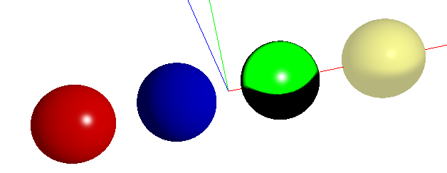

Self grading:

Hosein: never showed up or emailed back.

Floyd:

• Contribution: on a scale from 1-3, how much did the team member contributed to the overall solution?

0.5, we met once in Friday, but since his computer didn’t work, I myself tried to run the sample code on my computer. Then he didn’t show up on Tuesday, Wednesday as expected. He then emailed me on Thursday afternoon, by that time, I already finish all the coding myself. I still share my code with him though.

• Approachable: on a scale from 1-3, how easy was it to connect / contact the team member and how responsive was he/she?

0.5. We should meet after class on Tuesday, but he didn’t come to class.

• Solution: on a scale to 1-4, how would you rate the quality of the contribution of this team member (for instance, code does not work: 1. Code works perfectly without any adaptations: 4) ?

1. He didn’t have actual contribution, since his computer didn’t work and he didn’t show up.